Kindergarten Supply List 2017-2018

Please bring supplies listed below to Meet and Greet in a bag with your child’s name on the bag. Please do not label each item as some items will be shared.

- Fiskars 5” Blunt Scissors
- 1 Yellow Spiral Notebook-1 subject, wide ruled
- 1 Red Spiral Notebook- 1 subject, wide ruled
- 2 Primary Journals-see below
- 1 Green 3 prong pocket folder
- 1 Blue 3 prong pocket folder
- 2 Hi-Polymer Erasers (white)
- Crayola 12 count, washable markers, fine point
- Crayola 12 count pre-sharpened colored pencils
- 4 boxes of Crayola Crayons- (24 pack)
- Elmer’s glue sticks (8)large, (2)small
- 2 boxes of Kleenex tissues
- Number 2 pre-sharpened pencils (12 pack)
- Black Expo dry erase markers (4 pack) chisel tip, (4 pack) fine tip
- 1 Backpack-standard size (must hold a 9x12 folder) No Wheels
- 1 rest mat (48” long x 21”wide x 1”thick) No sleeping bags, yoga mats, towels, cots or daybeds- see below

*Boys- hand sanitizer, gallon sized Zip-lock bags, 2 paper towels
*Girls- quart & snack Zip-lock bags, 1 container of Wet Wipes

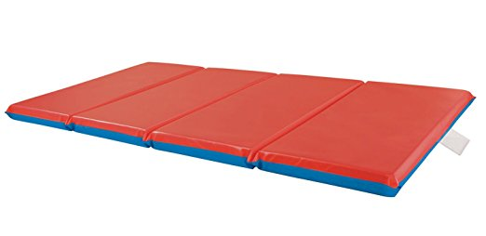
Examples:
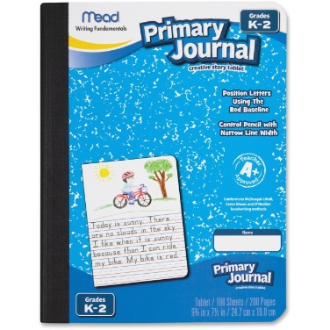

Ms. Gillespie’s Class Only:

- Please bring in a brown youth sized t-shirt by August 18th. We will be wearing the shirt in for our November feast but we will need to decorate them before then.

